System Requirements Statement (SRS) - Restaurant Billing System

Table of Contents

- Introduction
- Functional Requirements
2.1. Admin Module
2.2. Waiter Module
2.3. CookModule
2.4. CustomerModule
2.5. Use Case Diagram

1. Introduction
This document describes the business requirements and scope for the Restaurant Billing System (PayPlate). It follows the structure of the original document while keeping the information focused on the system’s purpose, background, goals, and involved users. The purpose of this SRS is to clearly define what the PayPlate system aims to achieve and how it will support restaurant operations through accurate and efficient billing.
Many restaurants still rely on paper-based billing or outdated systems that do not offer proper integration or automation. These traditional methods often lead to billing delays, calculation mistakes, slow order processing, and difficulty in maintaining sales records. As restaurants grow or deal with high customer volume, such problems become more noticeable and can negatively impact both staff productivity and customer satisfaction. The PayPlate system is designed to solve these issues by automating the billing workflow, integrating order details, menu items, discounts, and taxes into a single system, and generating error-free invoices while maintaining complete payment records. The system also provides real-time sales and performance analytics, making it useful for restaurants of all sizes.
The major goals of PayPlate include streamlining the billing process with automatic price fetching, tax calculations, and invoice creation. The system aims to enhance accuracy and speed in generating bills while supporting role-based access to ensure secure and organized operations within the restaurant. Another key goal is to improve customer satisfaction by enabling quick bill settlement, clear invoice details, and smooth payment processing.
The primary customers of the system are waiters or serving staff who need to place orders quickly and accurately, dine-in customers who expect clear and fast billing, and restaurant owners who require complete visibility of daily billing activities and revenue. Key stakeholders include restaurant owners and customers.
This introduction provides the foundation for understanding the system’s requirements and scope.

2. Functional Requirements
No | BRS ID | Requirement | Description
2.1 | Admin Module
2.1.1 | A1 | Create Account | Admin can create user accounts for staff members.
2.1.2 | A2 | Login | Admin login authentication process
2.1.3 | A3 | Add Menu | Admin can add new menu items.
2.1.4 | A4 | Delete Menu | Admin can delete existing menu items.
2.1.5 | A5 | Update menu | Admin can update name, price, or details of menu items.
2.1.6 | A6 | View Transactions | Admin can view all completed transactions.
2.1.7 | A7 | View Customers | Admin can view the list of all registered customers.
2.1.8 | A8 | View Orders | Admin can view all customer orders and their statuses.
2.1.9 | A9 | View Feedback | Admin can view customer feedback
2.2 | Waiter Module
2.2.1 | W1 | Login | Waiter can login.
2.2.2 | W2 | Update Profile | Waiter can update personal information.
2.2.3 | W3 | Create Order | Waiter can create a new customer order.
2.2.4 | W4 | Update Order | Waiter can modify an existing order.
2.2.5 | W5 | Serve Order | Waiter can make order status
2.2.6 | W6 | Generate Bill | Waiter can generate the bill for an order.
2.3 | Cook Module
2.3.1 | C1 | Login | Cook can login
2.3.2 | C2 | Update Profile | Cook can update personal details.
2.3.3 | C3 | View Orders | Cook can view all assigned or pending orders.
2.3.4 | C4 | Update Status | Cook can update cooking status (e.g., Preparing, Ready).
2.3.5 | C5 | Add Comments | Cook can add comments such as delay notes.
2.4 | Customer Module
2.4.1 | CU1 | Register | Customer can registter
2.4.2 | CU2 | Login | Customer can login
2.4.3 | CU3 | View Menu | Customer can view available menu items.
2.4.4 | CU4 | Create Order | Customer can place a new order.
2.4.5 | CU5 | View Order | Customer can view current or past orders.
2.4.6 | CU6 | View Bill | Customer can view the generated bill.
2.4.7 | CU7 | Pay bill | Customer can pay the bill online.
2.4.8 | CU8 | Give Feedback | Customer can submit feedback.
2.4.9 | CU9 | View Order Status | Customer can track the order status.

2.1 Admin Module – Detailed Processes

The Admin Module is the central control unit of the Restaurant Billing System.

The Admin manages user accounts, menu items, transactions, customer details, orders, and feedback.

Each function is described in detail below.

2.1.1 Create Account Process (A1)

The Restaurant Billing System allows the Admin to create new user accounts for Waiter, Cook, or other staff roles.

The account creation process ensures secure and valid registration of staff members.

Admin enters required information for new user account:

Full Name

UserID (unique)

Password

Role (Waiter / Cook / Admin)

Phone Number

Email Address (optional)

System performs validation checks:

UserID must be unique.

Password must follow the system policy:

8–16 characters

Must include uppercase letter, lowercase letter, numeric figure, and a special character

Phone number must be numeric and meet length requirement.

Role must be selected correctly.

If any validation fails:

The system displays an error message and rejects the account creation.

After successful validation:

The system stores the new account details.

The new user account is marked as Active by default.

A confirmation message appears for the Admin (e.g., “User account created successfully”).

Admin can later modify or deactivate this account from user management section.

2.1.2 Login Process (A2)

Admin must log in to the system using the assigned UserID and Password.

The login process ensures that only authorized admins access system functions.

UserID and Password Verification

The system checks whether the entered UserID exists.

The system verifies the password linked with the UserID.

If incorrect, authentication is denied.

User Type Verification

The system confirms that the user role is “Admin”.

If the role is not Admin, login access is denied.

Account Status Verification

The system checks if Admin account is active.

If suspended or deleted, access is denied.

Successful Login

Admin is redirected to the Admin Dashboard, which contains:

– Menu Management

– User Management

– Customer Records

– Order Records

– Transactions

– Feedback Overview

2.1.3 Add Menu Item Process (A3)

The Admin manages the restaurant menu.

The Add Menu process allows new dishes to be added to the system.

Admin enters details of the new food item:

Item Name

Description

Category (Starter / Main Course / Dessert, etc.)

Price

Availability (Available / Not Available)

System validation:

Item name must be unique.

Price must be numeric and greater than zero.

Category must be selected from predefined list.

If invalid, the system rejects the entry and displays an error message.

After successful validation:

The system saves the new menu item.

The item becomes visible to Customers, Waiters, and Cooks.

A success message is shown (“Menu Item Added Successfully”).

2.1.4 Delete Menu Item Process (A4)

Admin can delete menu items that are obsolete or no longer served.

Admin selects the menu item from the list.

System checks:

Whether the item exists.

Whether the item is linked to any active order.

If the item is used in active orders:

System prevents deletion and shows a warning.

If deletion is allowed:

The item is removed from the menu list.

It immediately becomes unavailable for ordering.

Confirmation message is displayed.

2.1.5 Update Menu Item Process (A5)

Admin can modify existing menu details.

1. Admin selects the item to update.

Fields that can be modified:

Item Name

Description

Price

Category

Availability Status

2. System validates updated values:

Price must remain numeric.

Item name cannot duplicate an existing one.

Availability status must be selected.

3. On successful update:

The system saves the new values.

Updated details appear instantly for all users.

The system shows a success message.

2.1.6 View Transactions Process (A6)

Admin can view all payment transactions completed in the restaurant system.

This helps in monitoring business revenue.

1. System displays all transaction details:

Transaction ID

Order ID

Customer Name

Amount

Payment Method (Cash / Card / UPI)

Payment Date

Payment Status

2. Admin can filter transactions by:

Date

Customer

Payment method

Amount range

3. Transactions cannot be edited by Admin.

Admin can only view and download reports.

2.1.7 View Customers Process (A7)

Admin can view details of all registered customers.

Information displayed:

Customer ID

Customer Name

Contact Details

Order History Count

Outstanding Bills (if any)

Admin uses this data for:

Service quality monitoring

Customer support

Customer pattern analysis

2.1.8 View Orders Process (A8)

Admin can monitor all orders placed in the system.

System shows order details:

Order ID

Customer or Table Number

Items Ordered

Assigned Cook

Order Status (Pending/Preparing/Ready/Served)

Total Bill

Timestamp

Admin cannot edit orders, but can only view them for monitoring.

2.1.9 View Feedback Process (A9)

Admin can view feedback submitted by customers.

Feedback helps in improving service and food quality.

2.2 Waiter Module

The Waiter Module handles all order-related operations in the Restaurant Billing System. It allows waiters to log in, update their profile, create customer orders, modify existing orders, and mark orders as served. The module also enables waiters to generate accurate bills for completed orders and manage table-wise order flow efficiently. Overall, it ensures faster service, fewer errors, and smooth coordination between order handling and billing.

2.1.1 Login Process (W1)
• The Restaurant Billing System always requires waiter authentication before accessing any system functions.
• The login process demands two inputs: UserID and Password.
The system performs the following checks:

1. Validation of Credentials
• The UserID and Password must match the values registered by the waiter.
• If either value is incorrect, access is denied.

2. Verification of User Type
• The User Type linked with the UserID must be “Waiter”.
• If the user type does not match, the waiter cannot access the waiter dashboard.

3. Account Availability
• The Admin has the authority to enable or disable waiter accounts.
• If the account is disabled, login is not permitted.
• Only when all validations are successful, the waiter is redirected to the Waiter Home, which contains the following operational options:
- A link to logout
- A link to update profile
- A link to change password
- A link to create customer order
- A link to update customer order
- A link to view active orders
- A link to serve an order
- A link to generate bill

2.1.2 Update Profile Process(W2)
• The system shall allow waiters to update their personal and contact information after successful authentication.

Updatable Information Includes:
- First Name
- Last Name
- Email Address
- Contact Number
- Permanent Address
- Security Question & Answer
• All fields are compulsory in nature, but updating them is optional.
• When updating the profile:

Profile Update Rules:
- The new values must follow the input constraints (such as valid email format, character limit, etc.).
- The waiter must enter the correct current password before saving changes (if required by admin policy).
- All updates are stored immediately in the system database.
Once the update is complete, the system shows a confirmation message indicating successful profile modification.

2.1.3 Create Order Process (W3)
- A waiter can create a new customer order only after successful login.

Order Creation Requires:
- Table Number
- Menu Items selected from system menu
- Quantity of each item
- Any special instructions or notes (optional)

Order Creation Steps:
- Waiter selects the table for which the order is being created.
- Menu items are displayed along with categories and prices.
- Waiter chooses the required items and specifies quantities.
- Waiter may add special notes (e.g., less spicy, extra cheese).
- The system calculates the preliminary subtotal of selected items.
- The order is saved and assigned a unique Order ID.

After Order Creation:
- The order is visible in the “Active Orders” list.
- Kitchen can view the order details if kitchen module exists (optional).
- Waiter can update or cancel the order until it is served.
- The order remains active until it is either cancelled or marked as served.

2.1.4 Update Order Process(W4)
• Waiter can modify an existing order that has not yet been marked as “Served.”

Information That Can Be Updated:
- Menu Items (add or remove)
- Quantity of items
- Special Instructions
- Change table number (if required)

Update Order Rules:
- Order must be in Active status.
- Once served, no modification is allowed.
- If the order is partially prepared in the kitchen (future module), system may restrict certain updates.

Steps in Update Order Process:
- Waiter selects the order using Order ID.
- The system displays existing items and their quantities.
- Waiter performs necessary changes.
- The system recalculates the updated subtotal.
- Updated order details are saved in the database.
- A confirmation message is shown.
• The updated order is then reflected in the order dashboard and can be served when ready.

2.2.5 Serve Order Process (W5)
• The Restaurant Billing System enables the waiter to mark an order as Served once the items have been delivered to the customer.

Serve Order Requirements:
- The order must exist in the system.
- The order must currently be in Active or Prepared status.
- The order must not be cancelled or already served.

Serve Order Steps:
- The waiter selects the specific order by using the Order ID.
- The system displays the complete order details, including:
  - Table number
  - Items and quantities
  - Special notes
  - Current order status
- The waiter confirms that the customer has received the order.
- The waiter updates the status to “Served” using the provided option.
- The system stores the updated status immediately in the database.

Serve Order Rules:
- Once the order is marked as Served, no further modification to items or quantities is allowed.
- The order becomes eligible for Bill Generation (W6).
- If necessary, the system may allow adding a remark related to serving (optional future enhancement).
• After the action is completed, the system displays a confirmation message:
“Order successfully marked as Served.”

2.2.6 Generate Bill Process (W6)
• The Restaurant Billing System provides a function that allows the waiter to generate a bill for any order that has been fully served.

Preconditions for Bill Generation:
- The order must be in Served status.
- The order must not be cancelled.
- All items must have valid pricing in the system.

Bill Generation Steps:
- The waiter selects the order by Order ID from the “Served Orders” list.
- The system retrieves all order details including:
  - Table number
  - List of food items
  - Quantities
  - Item prices
  - Subtotal
- The system automatically calculates:
  - Item-wise total
  - Tax amount (as configured by admin)
  - Grand total
- The waiter verifies the details and confirms bill generation.
- The system generates a digital bill and assigns a unique Bill ID.

Bill Output Options:
- Display bill on screen
- Print bill (if printer connected)
- Save bill as PDF
- Show QR code for digital payment (future feature)
- Mark the bill as paid for cash payment

Postconditions:
• The bill is stored in the billing database.
• The bill becomes visible to the admin in the Billing Records section.
• The order status is updated to “Completed” after payment.

Bill Generation Rules:
- No item can be added or removed after the bill is generated.
- If any discrepancy is found, the waiter must create a correction order (future feature).
- Discounts can be applied only if enabled by admin.
• After bill issuance, the system confirms:
“Bill generated successfully.”

2.3 CookModule

2.3.1 Cook Login Process (C1)

The Restaurant Billing System always requires Cook authentication before allowing access to any cooking features.

Login requires UserID and Password, and both are verified in three essential steps to ensure security.

The login process is described below.

1. First, the UserID and Password should exist and be correct.

The Cook enters the UserID and Password on the login interface.

The system checks whether the entered UserID is registered.

Then the system checks whether the entered Password matches the password saved for that UserID.

If the UserID or Password does not match with the registered information, authentication fails.
The system displays an appropriate error message (e.g., “Invalid credentials”).
After multiple wrong attempts, the account may be temporarily blocked (as defined in Admin rules).

2. Second, the User Type associated with the UserID should be “Cook”.

Each user in the system is linked with a role such as:
Admin, Waiter, Cashier, or Cook.

When the Cook tries to log in:

The system checks if the role stored for that UserID is “Cook”.

If the role is different (e.g., Waiter trying to access Cook module), authentication is not permitted.

The system informs the user that the login role is not authorized for this module.

3. Third, the UserID should be active.

The Admin controls the activation/deactivation of all user accounts.

The system checks whether the Cook’s account is in active status.

If the account is suspended, removed, or temporarily blocked, login is denied.

The system displays a message (e.g., “Account inactive. Contact Administrator.”)

Only if all three checks succeed:

The Cook is redirected to the Cook Home Page.

The Cook Home Page provides access to:
– View Orders
– Update Order Status
– Add Comments
– Update Profile

2.3.2 Update Profile Process (C2)

The Cook can update personal details after successful authentication.

Update Profile helps the Cook keep their information accurate and secure.

The update process is described as below.

1. The Cook must enter current password for verification.

Before making any changes, the system asks for the existing password.

This prevents unauthorized profile edits.

If the current password is incorrect, the update process is terminated.

2. The Cook can update the following personal details (based on system design):

Full Name

Phone Number

Email Address

Profile Picture (optional)

Password (optional)

3. The system validates the updated information.

Name must contain only alphabetic characters.

Email must follow valid format (e.g., abc@example.com).

Phone number must contain only numeric digits (usual length 10 digits).

If password is changed:
New password must be 8–16 characters.
Must contain at least:
– One uppercase letter
– One lowercase letter
– One digit
– One special symbol
New password must be entered twice to avoid typing mistakes.

4. Once all checks are successfully completed:

The system saves the updated details.

A confirmation message is shown (e.g., “Profile updated successfully”).

If password was changed:
The system logs out the Cook.
Re-login with the new password is required.

2.3.3 View Orders Process (C3)

The Cook can view all food orders assigned to them or pending in the kitchen.

The purpose is to give the Cook a clear understanding of what needs to be prepared.

1. Orders are categorized into:

a) Pending Orders

Orders that are newly placed and not started by any Cook.

b) In-Progress Orders

Orders already being prepared.

c) Completed (Ready) Orders

Orders marked as Ready by the Cook.

2. For each order, the system displays:

Order ID

Table Number (if dine-in)

Items and quantity

Special instructions given by customer

Order time

Expected preparation time

Status (Pending / Preparing / Ready)

3. The Cook can select any order to perform actions.

View full order details
Start preparation (changes status)
Add comments
Mark as Ready

The system restricts editing of order items — only viewing is permitted.

4. The order list is dynamically updated:

New orders appear automatically or can be refreshed manually.
When a Cook updates a status, that order moves to the relevant list.

2.3.4 Update Status Process (C4)

This function allows the Cook to update the progress of an order.

Status updates help Waiters and Cashiers track order readiness.

There are generally two main statuses:

1. Preparing

Indicates the Cook has started making the order.

2. Ready

Indicates the food is fully prepared and can be served.

1. When the Cook selects “Preparing”:

The system records the timestamp (start time).

The order is moved from Pending → In-Progress.

The Waiter or Billing Counter may receive a notification.

2. When the Cook selects “Ready”:

The system records the completion timestamp.

The order is moved from In-Progress → Ready List.

The Waiter receives an alert to pick up the food for serving.

3. Validation rules:

Only an assigned Cook can update the status of that order.

Cook cannot revert from “Ready” back to “Preparing”.

Cook cannot mark order as “Ready” without first marking it “Preparing”.

Some systems may prevent marking Ready if mandatory comments are required.

4. If the update succeeds:

The system displays a success message (e.g., “Order marked as Ready”).

Order list updates automatically.

2.3.5 Add Comments Process (C5)

Comments allow the Cook to communicate issues or additional information related to an order.

Comments improve coordination between Cook, Waiter, and Cashier.

1. The Cook selects an order from the View Orders list.

The system opens a comment input window.

2. Types of comments the Cook may add:

Delay note (e.g., “Oven busy, need 10 more minutes”).

Ingredient issues (e.g., “Mushrooms unavailable, replaced with onions”).

Customer-related notes (e.g., “Less spicy as requested”).

Preparation alerts (e.g., “Item needs to be served hot”).

Internal chef-to-waiter messages (based on policy).

3. The system validates the comment:

Comment should not exceed maximum character limit (e.g., 200–250 characters).

Offensive or restricted words may be blocked by the system.

Empty comments are not accepted.

4. Once the comment is added:

The system timestamps the comment.

The comment is stored with the order record.

Waiter and Billing Staff can immediately view the comment.

Admin may review historical comments for quality checks.

2.4 Customer Module

The Customer Module is designed to manage all customer-related activities in the Restaurant Management System. This module allows customers to create an account, explore the menu, place orders, pay bills, and share feedback. It ensures a smooth, user-friendly experience for the customer while maintaining secure and real-time interaction with the system.

2.4.1 Register (CU1)

Customer Account Registration Process
The system allows a new customer to create an account to access all restaurant services.
- Customer enters required registration details:
  - Full Name
  - Email ID (unique)
  - Phone Number
  - Password
  - Confirm Password
- System performs validation checks:
  - Email must be unique and valid.
  - Phone number must be numeric and 10 digits.
  - Password must meet security rules (8–16 characters).
  - Password and Confirm Password must match.
- If any validation fails:
  - System shows an error message and stops the registration process.
- After successful validation:
  - System stores the customer details in the database.
  - Account status is set to Active by default.
- System displays confirmation message:
“Registration successful. Please login to continue.”

2.4.2 Login (CU2)

Customer Login Authentication
- Customer enters:
  - Email / Phone
  - Password
- System checks:
  - Whether the account exists.
  - Whether the password is correct.
  - Whether the account is Active.
- If any check fails:
  - Error message is shown: “Invalid credentials” / “Account not active.”
- On success:
  - Customer is redirected to the dashboard/home page.
  - System creates a secure session for the logged-in customer.

2.4.3 View Menu (CU3)

Viewing Available Menu Items
- Customer opens the Menu page.
- System retrieves:
  - Food categories (e.g., Starters, Main Course, Drinks)
  - Item name, description, price, availability
- Customer can:
  - Browse items
  - Filter by category
  - Check availability
- System displays real-time updated menu.

2.4.4 Create Order (CU4)

Placing a New Order
- Customer selects food items from the menu.
- Customer can:
  - Add items to the cart
  - Increase/decrease quantity
  - Remove items from cart
- System calculates:
  - Item total
  - Taxes
  - Final bill amount
- Customer confirms the order by clicking Place Order.
- System generates:
  - Unique Order ID
  - Order date & time
- Order is forwarded to the kitchen/cook panel.
- System displays confirmation message:
“Order placed successfully.”

2.4.5 View Order (CU5)

Viewing Current or Past Orders
- Customer opens the “My Orders” section.
- System displays:
  - Current orders
  - Previous completed orders
  - Order details (items, quantity, amount, order ID, date, time)
- Customer can view full order summary anytime.

2.4.6 View Bill (CU6)

Customer Bill Generation and Viewing
- Customer selects an order to view its bill.
- System fetches:
  - Item-wise details
  - Total amount
  - GST
  - Service charges (if any)
  - Final payable amount
- The bill is shown in readable format.
- Customer can choose to pay from this screen.

2.4.7 Pay Bill (CU7)

Online Bill Payment Process
- Customer clicks on Pay Now.
- System redirects to the secure payment gateway.
- Customer selects payment method:
  - UPI
  - Card
  - Net banking
  - Wallet
- After payment confirmation:
System updates order status on Paid.
- System displays success message:
“Payment successful.”

2.4.8 Give Feedback (CU8)

Customer Feedback Submission
- Customer opens the Feedback form.
- Customer enters:
  - Rating (1–5 stars)
  - Comments (optional)
- System validates:
  - Rating must not be empty.
- On submit:
  - Feedback is saved in the database.
  - Admin can view feedback later.
- System shows message:
“Thank you for your feedback!”

2.4.9 View Order Status (CU9)

Order Status Tracking Process
- Customer opens Order Status section.
- System displays real-time status:
  - Order Placed
  - Accepted
  - Preparing
  - Ready for Pickup / Out for Delivery
  - Completed
- Status automatically updates based on kitchen actions.
- Customer can refresh or view updates anytime.
- Once completed:
  - System marks order as Delivered/Completed.

2.5 Use Case Diagram
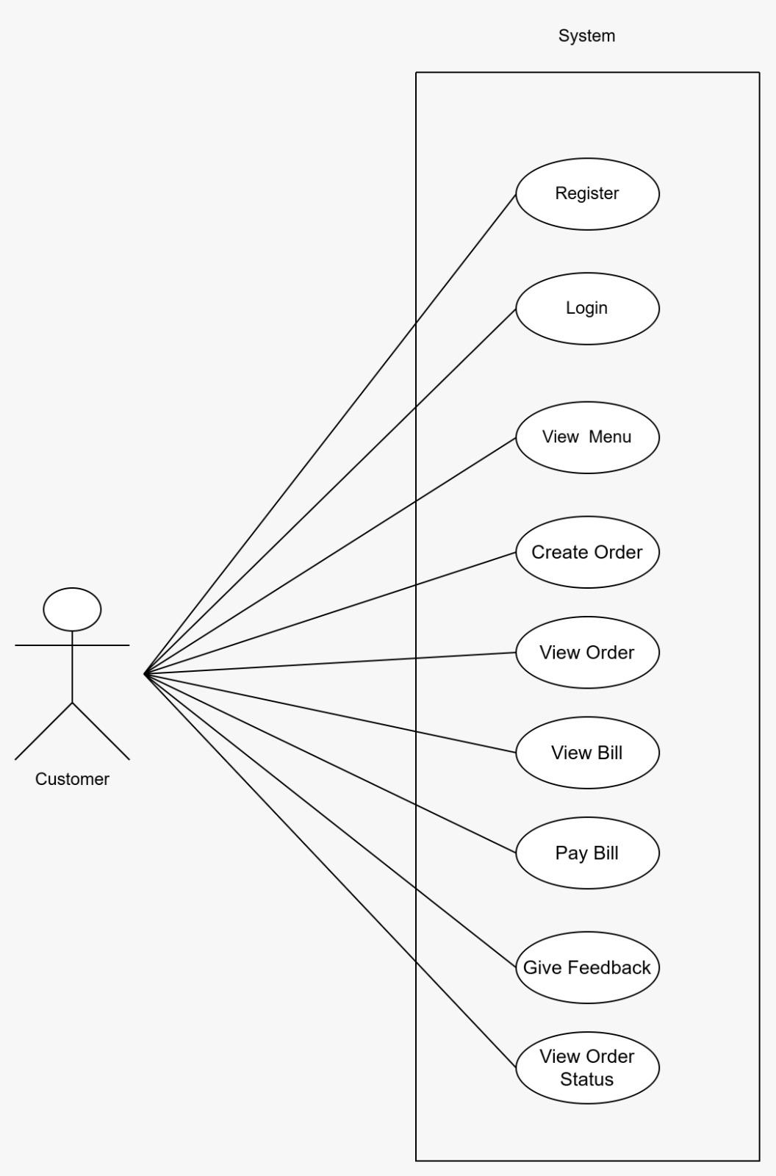
Customer :

Admin :
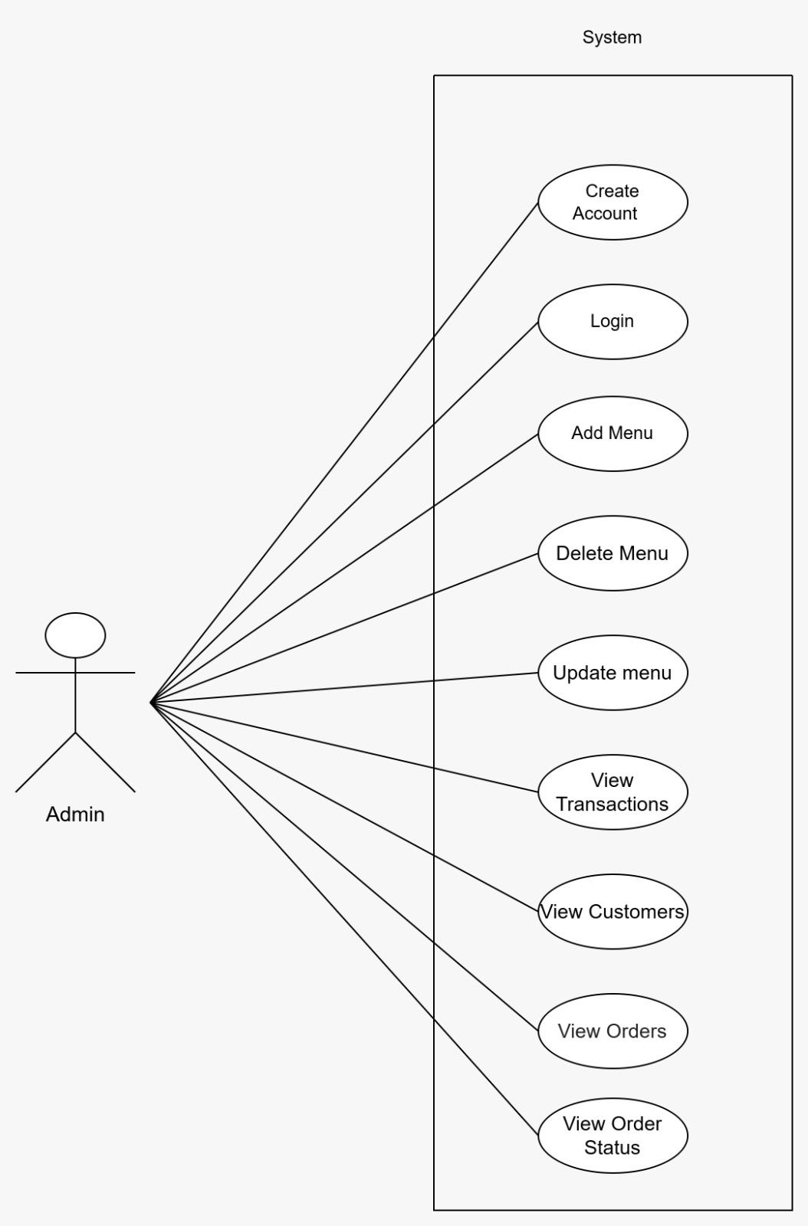

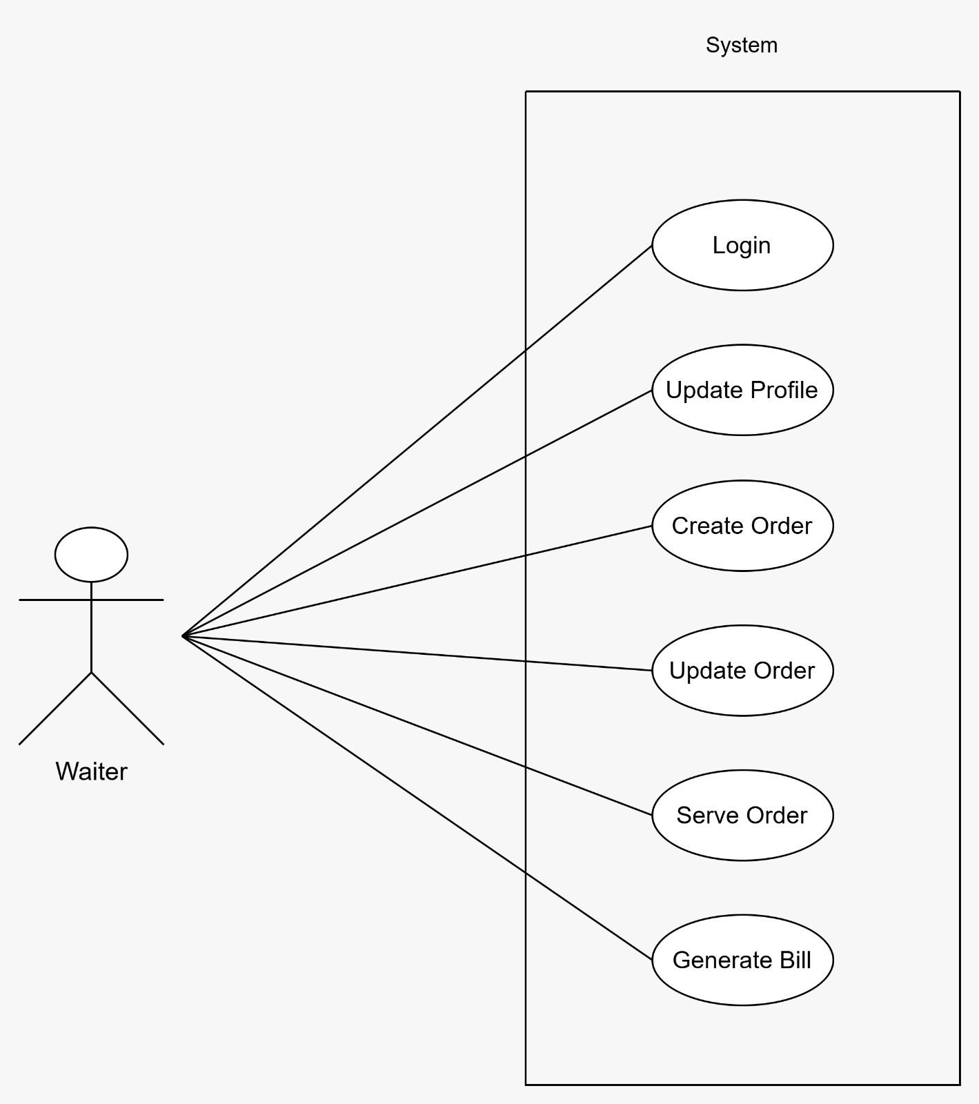
Waiter :

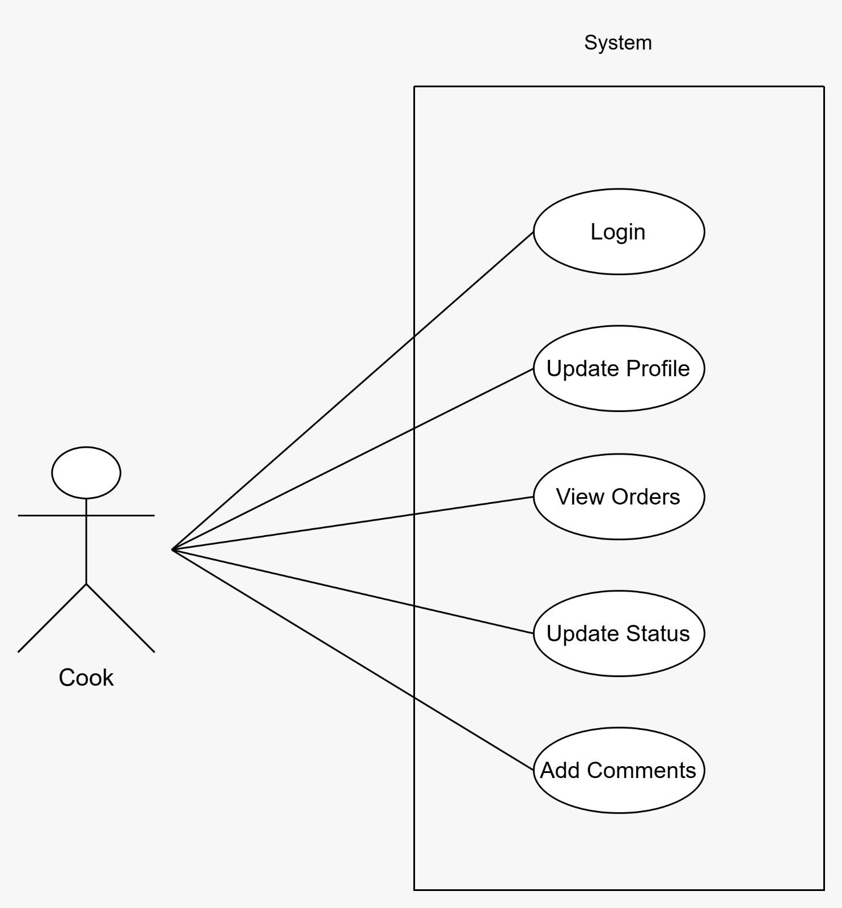
Cook :

